`

Private Dining Planner

Welcome

Thank you for choosing Artisans Cuisine & Savoir-faire for your event. This private dining planner will assist you in making the best decisions for your event. Included in this packet is information on our private dining rooms, menu options, and pricing.

We look forward to providing you with exceptional cuisine and service to create a memorable experience for you and your guests!

For more information please
Contact Suzanne Morgan at
713-529-9111 or via email at
Suzanne@artisansrestaurant.com

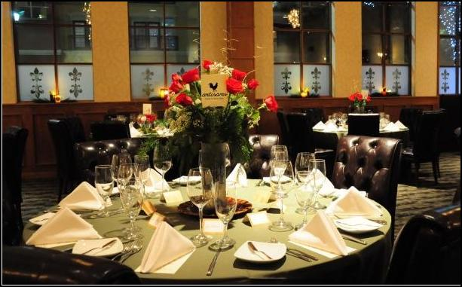

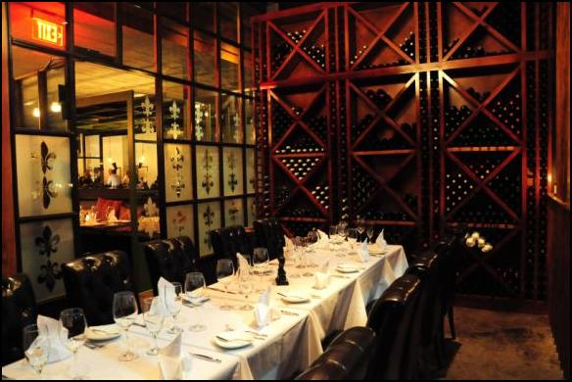

General Event Information
Artisans is home to four separate event spaces

Medieval Room I or Medieval Room II
accommodates up to 12 people
$800 Dinner Food & Beverage Minimum

Medieval Room I & II combined
accommodates up to 24 people
$1,600 Dinner Food & Beverage Minimum

La Veranda
accommodates up to 14 people
$1000 Dinner Food & Beverage Minimum

Le Grande Salon
Accommodates up to 100 people
Food & Beverage Minimum upon request

Food and Beverage Minimums/Guarantees

Artisans utilizes food and beverage minimums for our private event spaces. These minimums are dependent upon: event space, day of the week and time of year. The food and beverages minimums are also subject to state tax (8.25%) and service charge (8%) and gratuity (15%). Should a minimum spend not be met, the remaining balance will be assessed in a room rental fee. All events are subject to a final guarantee (or head count) required 48 hours prior to event time. Charges are based on final guarantee or number served; whichever is greater. Should no guarantee be given the number estimated for the room reservation will be used for the final guarantee. For further information on pricing please call Suzanne Morgan at 713.529.9111

Menu Details

For events with more than fifteen (15) people a limited or prix fixe menu is required. Ala Carte menu is available for parties of fifteen (15) or less. Artisans allows substitutions to ensure the culinary needs of all guests are met including those individuals with allergies and/or dietary restrictions (i.e. vegetarian or gluten free). Please alert your event manager in advance so we may best accommodate these requests.
All cocktails are charged per drink based on consumption while wine is charged per bottle. You are, of course, only charged for wine that is opened. All event wine(s) must be finalized 10-days prior to your event to ensure availability. Unfortunately, due to TABC regulations Artisans does not allow outside wine or alcohol to be brought into the restaurant under any circumstances.

Cancellation Policy

Event dates are considered firm at the time a “Private Room Agreement” is signed and deposits and/or security holds are made. For parties with less than 10 people a valid credit card number is required to hold the room. For those events with 10 guests or more a non-refundable deposit is required. We understand due to unforeseen circumstances that events will occasionally be cancelled. If your event is cancelled six months prior 100% of your deposit will be applied to a future event. If you cancel three to six months prior 50% of your deposit will be applied to a future event. And unfortunately, those events canceled within a 90-day period, are not eligible for any portion of the non-refundable deposit.

Chef Selected Gastronomique Tasting Menus

The Chef’s Selected Gastronomique Tasting Menus are seasonal menus specially created and prepared by the chefs at Artisans. These menus are set menus and may only be modified in the event that an individual has a food allergy or dietary health concern. Tasting menus are also available with a wine pairing option.
Six Course
$108 per Person

Add Wine pairing+ $60

Amuse Bouche

Le Foie Gras

Pan Seared Foie Gras, Saffron Poached Pear
Baklava, Crème de Cassis Demi-Glace
La Noix de Saint-Jacques
Pan Seared Scallops, Spinach Ravioli

Beurre Blanc
Served with Lobster Cappuccino
Le Poisson du Pacifique
Pistachio Crusted Chilean Seabass
Creamy White Wine Risotto
Baby Bok Choy, Saffron Velouté
Sorbet au Champagne
Le Filet de Boeuf au Poivre

Black Pepper Crusted Beef Tenderloin
Fingerling Potatoes Rôties, Haricots Verts
Green Peppercorn Sauce
Gâteau Mousse Chocolat

Chocolate Mousse,
Cookie Crumble, Macaroon
Seven Course
$119 per person

Add Wine pairing+ $70

Amuse Bouche

Le Foie Gras

Pan Seared Foie Gras, Saffron Poached Pear
Baklava, Crème de Cassis Demi-Glace
La Bisque de Homard
Lobster Bisque, Lobster, Tomato Confit
Le Vivaneau Rouge du Golfe
Seared Red Snapper
Corn Risotto, Sauteed Spinach
Black Garlic Beurre Blanc
Sorbet au Champagne
L’Agneau Rôti

Roasted Lamb Loin, French Mashed Potatoes
Corn Galette, Haricots Verts, Au Jus
Le Fromage
Spice Poached Pear, Blue Cheese
Walnuts, Microgreen Salad

Gâteau Opéra
Joconde Cake, French Buttercream
Silky Ganache

The price per person excludes beverages and is subject to tax (8.25%) service charge (8%) and gratuity (15%)

3201 Louisiana Street | Suite 110 | 713.529.9111 | Houston, Texas 77006 | www.artisansrestaurant.com

Butler Passed Hors d’Oeuvres
All events and dinners at Artisans have the option to be served
passed hors d’oeuvres prior to being seated for dinner.

3 Selections $19
6 Selections $34
10 Selections $64

- Tomato Bruschetta | - Roasted Tomato Gazpacho | - Smoked Salmon Canapés | - Escargot a la Bourguignonne
- Quail Leg Confit | - Miniature Beef Wellington | - Miniature Crab Cakes | - Tomato Tartin
- Seafood Ceviche | - French Scrambled Eggs with Caviar | - Curry Chicken Salad on Endive | - Classic French Beef Tar Tar
. French Scrambled eggs | - Mini Brie En Croute with Apple Jam | - Lobster “Cappuccino” | - Seared Ahi Tuna with Pickled Veggies
- Goat Cheese Stuffed Roasted Baby Heirloom Tomatoes | - Truffle Vichyssoise | - Beef Skewers | - Grilled Cheese  Foie Gras Sandwich
- Smoked Salmon Mousse |  | - Mussels & Frites | - Tuna Tar Tar

The price per person excludes beverages and is subject to tax (8.25%) service charge (8%) and gratuity (15%)

3201 Louisiana Street | Suite 110 | 713.529.9111 | Houston, Texas 77006 | www.artisansrestaurant.com

Dinner Menus
$98 Per Person

Passed Hors D’oeuvres
(Optional -- $19 per person)
Tomato Bruschetta
Mini Crab Cakes
Petit Beef Wellingtons

First Course (Choose 2)
La Salade Artisans  Mixed Greens, Caramelized Bacon  Parmesan, Lemon Vinaigrette | Crème Dubarry  Creamy Roasted Cauliflower Potage  Parmesan, Sultanas Raisin | La Salade Ceasar  Romaine, Strawberries  Roasted Corn, Parmesan  Fried Tortilla, Avocado
La Noix de Saint-Jacques  Seared Scallop, Spinach Ravioli  Beurre Blanc, Lobster Cappuccino  (Add $15 per order) | Escargot á la Bourguignonne  Baked Escargot  Almond Garlic Butter  Toasted Brioche  (Add $15 per order) | La Bisque de Homard  Lobster Bisque, Lobster Tomato Confit  (Add $16 per order)

Entrée Course (Choose 3)

Filet de Boeuf au Poivre  Pepper Crusted Beef Tenderloin Fingerling Potatoes Rôties  Haricots Verts  Green Peppercorn Sauce  (Add $10 per order) | Poisson du Pacifique  Pistachio Crusted Chilean Seabass  Creamy White Wine Risotto  Baby Bok Choy, Saffron Velouté | La Volaille  Roasted Frenched Chicken Breast  Parmesan Risotto, Asparagus  Armoricaine Sauce  (Add $15 per order for Lobster Tail)
Faux Filet et son Homard  Seared New York Strip, Lobster Tail  Asparagus  Truffle Au Gratin Potatoes  Lobster Hollandaise  (Add $18 per order) | Saumon Atlantique  Atlantic Salmon  Moroccan Couscous Asparagus  Harissa Beurre Blanc | Le Poisson Redfish  Du Golfe du Mexique  Pan-Seared Texas Redfish  Corn Risotto, Sauteed Spinach  Black Garlic Beurre Blanc
Dessert Course (Choose 2)

Gâteau Mousse  Chocolate Mousse Cake  Cookie Crumble Macaroon | Crème Brulée  Vanilla Bean | Gâteau Opéra  Joconde Cake, Coffee French Buttercream Silky Ganache
Add Soufflès
1 - 3 Per Table $25 each
(Served with Dessert Course)
Chocolate, Grand Marnier, Lemon

Finishing Touches

Audio/Visual Equipment
All of our private rooms are have state-of-the-art TVs that are perfect for business presentations, videos and photo slideshows. The TVs easily sync with MOST HDMI compatible computers/tablets/devices and are visually situated to ensure every guest has a great view no matter their location. Additionally, the room can be used to play pre-selected music lists during your event making it even more special for you and guests. With ever evolving technology and platforms, Artisan cannot guarantee your device compatibility thus we highly encourage you to arrive at least one hour prior to your function to ensure compatibility with our system. You may also set an appointment in advance of your program to test equipment. All HDMI Cables, power cords/sources and Apple adapters are at the exclusive requirement of the client.

Large Screen TVs $150 in Medieval & Veranda Room
Salon Room AV Package
Podium, HDMI Connection, 2 Large Screens and Microphone

Floral Arrangements, Linen & Décor
Artisans is happy to provide floral arrangements for your special event. The cost per arrangement is approximately $45 to $175 each depending on the table layout and type of flowers chosen. Linens range from a variety of colors & textures to suit every color palate. Linen may range from $20-30 each for a basic design to $60 for a more intricate pattern.
Artisan’s offers complimentary white linens. We also offer an array of specialty linens to complement any color palette. Additionally, our trained event staff are willing and able to assist you with additional room and table décor suitable for every event and will work with you to ensure proper set up and tear down. However, please be aware that confetti and glitter are not permitted and no items such as pictures, posters or banners are to be hung on the walls or from the ceilings.
Cakes & Desserts
Artisans has a world-class pastry chef on staff who will work with you on custom cake orders, desserts or pastries if so desired. Please note: outside cakes, cupcakes and cake pops from a reputable and legitimate bakery are the only outside food allowed in the restaurant and must be confirmed with your event coordinator prior to the event. Charges of $5 per person for cake service may apply, please ask your Event Manager for more details. No outside beverages are allowed in the restaurant due to TABC laws and regulations.

Valet/Parking
There is complimentary self-parking in the garage behind the restaurant, please access via Stuart Street & Milam Street. Hosted valet is $12 per car and is accessible via Stuart Street.

3201 Louisiana Street | Suite 110 | 713.529.9111 | Houston, Texas 77006 | www.artisansrestaurant.com

